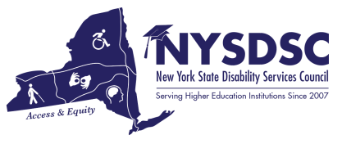

**Submission Date:**

6/14/2022

**Name of the Committee:**

Strategic Planning Working Group

**Committee Chair**:

Catherine Carlson, Columbia-Greene Community College

# Name of Committee Members and Affiliations:

Catherine Carlson, Chair, Columbia-Greene Community College; Nancy Carr, Onondaga Community College; Tamara Mariotti, Mohawk Valley Community College; Gabriella Vasta, SUNY Delhi; Lauren Rodriguez, SUNY Office of University Life

# Committee’s Goals and Objectives:

To create a 5-year Strategic Plan which provides traction to the Mission, Vision and Goals of NYSDSC by charting a course of collaborative partnerships and responsive, effective advocacy in support of inclusion for students with disabilities in higher education.

# Objectives In-progress/Pending:

During the Fall 2021 meeting, NYSDSC members were asked to provide input on updating the 2016-2021 Strategic Plan.

# Objectives Achieved: (summary)

The recorded comments and suggestions were incorporated into a Draft 2022-2027 Strategic Plan, which met the Working Group’s goals to be true to our Mission, Vision and Goals and also provided an action-based tract to those ideologies. The Draft Plan was presented to the membership on the ListServ for vetting.

# Announcements:

A Motion will be made on the floor of the Business Meeting to accept the Draft Plan, with any revisions suggested during the meeting, as the Final 5-year Strategic Plan and the web site will be updated accordingly.

# Questions or Concerns:

Committee Chairs are encouraged to review their Charges for alignment with the new Strategic Plan.

# Additional Notes: None