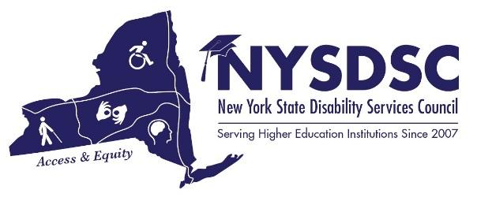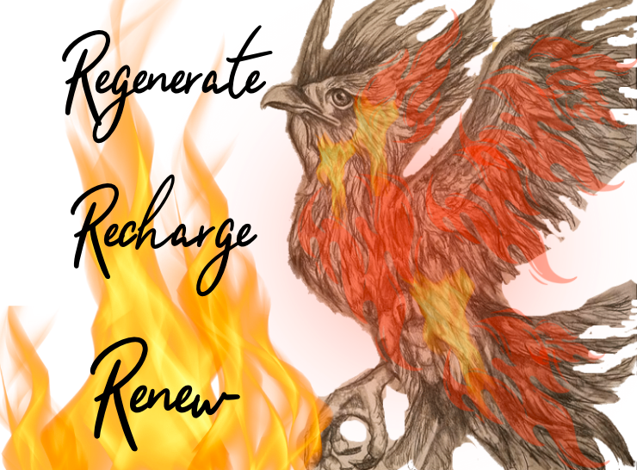

NYSDSC SPRING 2022 CONFERENCE AGENDA

Day 1: Tuesday, June 28th
08:30 to 09:25 am Greeting, Registration, and Coffee [Pre-function Room]

09:30 to 09:55 am Welcome Note, Don Pool, NYSDSC President - Jamestown Community College [Liberty I & II]

10:00 to 11:15 am KEYNOTE – Zebadiah Hall - Director of Student Disability Services, Cornell University [Liberty I & II]

Zebadiah Hall is the Director of Student Disability Services (SDS) at Cornell University. He has shifted SDS to a Civil Rights for Social Justice model instead of the medical model approach to determining accommodation. His pronouns are He, Him. Zebadiah has worked in higher education in various departments such as Admissions, Academic Support, Assistant Men's Basketball Coach, and Disability Support Services. He served as the President of the State of Indiana’s Association on Higher Education and Disability (AHEAD) chapter from 2013-2014. He is currently serving a three-year term as a board member of AHEAD's national organization as the Equity Officer. Before being the director at Cornell, he was the director of Access and Accommodation Resource Center at Valparaiso University and director at Calumet College of St. Joseph Disability Support Services as well. At Valparaiso, he served as the chair of the Staff Employee Advocacy Council and the chair of the Minority Employee Support Group. At Cornell, he currently sits on the Diversity Working Group for Cornell Health. He is a regular speaker and facilitator on topics around access and opportunity for disabled students as well as other oppressed populations. He is currently pursuing his Ph.D. in Leadership for the Advancement of Learning and Service in Higher Education at Cardinal Stritch University in Milwaukee, WI.

11:30 to 12:20 pm Concurrent Session #1

  - Equity and Inclusion beyond ADA and Section 504 [Liberty I & II]

Dr. Todd Alden Marshall, Equity and Inclusion Officer/CDO, MVCC
Chief Diversity Officers are continuing to become key stakeholders in promoting disability awareness and supporting existing accessibility programs on college campuses. It is imperative that we collaborate with coordinators and directors of accessibility. Our role in advancing cultural humility and cultural agility concerning disabilities extends beyond ADA and section 504. As CDO's we focus on equity and inclusion; however, how can we make sure that our work includes all students, regardless of their abilities? How can we be openly transparent in supporting and providing needed access and resources for students of all levels of abilities, ensuring that they are being treated fairly and feel like they belong?
1.2 New Professionals Training [Liberty III & IV]

Jean Vizvary - NYSDSC Secretary - Director of Disability Resource Center, SUNY New Paltz
Catherine Carlson - NYSDSC Past President - Director, Office of Accessibility Services, Columbia Greene Community College

This session will be a “mini boot camp” for new professionals; covering the topics that are most useful and helpful to people new to disability-related work in higher education.

12:30 to 1:25 pm Lunch [Liberty I & II]

01:30 to 2:20 pm Concurrent Session #2

2.1 Remote Learning as an Accommodation [Liberty I & II]

Don Pool, NYSDSC President - Jamestown Community College
DeAnne Martocci, NYSDSC President Elect - HVCC Director of Center for Access and Assistive Technology

Remote learning is new to Many of us. Many schools are seeing an uptick in requests for students to attend traditional classes remotely. Is this an appropriate accommodation? Is it a fundamental alteration? Is it doable? Because this is new territory, there are no good, solid answers. In a group discussion, we will explore this topic and attempt to come to a collective consensus on how to enter into these discussions with students, faculty and staff, and how to determine if, when, and how this may be appropriate.

2.2 New Professionals Training Continued [Liberty III & IV]

Jean Vizvary - NYSDSC Secretary - Director of Disability Resource Center, SUNY New Paltz
Catherine Carlson - NYSDSC Past President - Director, Office of Accessibility Services, Columbia Greene Community College

This session will be the continuation of the “mini boot camp” for new professionals; covering the topics that are most useful and helpful to people new to disability-related work in higher education.

02:35 to 03:25 pm Concurrent Session #3

3.1 Going it (Almost) Alone: Navigating Challenges in Small Student Disability Services Offices [Liberty I & II]

Vanessa Case, Coordinator of Accommodative Services & ADA/504 Compliance Officer, Paul Smith's College
Kris Percival, Accommodations Coordinator & Academic Center Director, St. Joseph's College, Brooklyn
We are very lucky to have NYSDSC colleagues an email away, but the day-to-day grind in a Student Disability Services Office as a lone disability officer (or one of a small number of staff) can be extremely challenging. What are some of the small-office challenges you have faced (and strategies you have created to deal with them)?
This is a Discussion and Debriefing Session, open to people who work in a "small" (under 4 staff members) office where your job is greater than your job description.

3.2 Help, I'm Not a Teacher of Visually Impaired (TVI)! [Liberty III & IV]

Annie Petersen, Coordinator of Accessibility- HVCC
DeAnne Martocci, NYSDSC President Elect - HVCC Director of Center for Access and Assistive Technology

This presentation will focus on our experiences in supporting students who are blind. We will discuss the resources we used to acquire knowledge, equipment, and funding. We will demonstrate the steps we took to make tactile images. This is an interactive presentation.

Day 2: Wednesday, June 29th

08:00 to 08:55 am Greeting, Registration, and Coffee [Pre-function Room]

09:00 to 05:15 pm Information Available All Day [Pre-function Room]

Visit The Vendors – An opportunity to visit the companies that produce assistive and adaptive technology for use by your students, and by your campus professionals

09:00 to 09:50 am Concurrent Session #4

4.1 Colleges Aides/Mentors [Liberty I]
Nancy Carr, NYSDSC – Treasurer -Director of Testing and Accommodative Services, Onondaga Community College
This panel will include at least one student, two advocates, myself and an agency representative from a local Syracuse not for profit. The role of aides and mentors on the campus will be explored from the perspective of the student and their partner mentor. Carr and Agency will talk about how such services can be coordinated. Processes through OPWDD and OMH will be shown.

4.2 Access Technology Open Forum [Liberty II]

Jeremy Zhe-Heimerman, Assistant Director, Disability Resources, SUNY Cortland
Karen Grella, Ph.D., Accessibility Specialist, Cayuga Community College
Cyrus Hamilton-Ferguson, Assistant Director of Student Disability Services and Disability Access Consultant, Cornell University
Sarah Bonawitz, Assistant Director of Student Disability Services and Disability Access Consultant, Cornell University

Bring your questions for the members of the NYSDSC Access Technology (AT) Committee.
Topics could include anything attendees ask, including technology-assisted note taking, online
course accessibility, text-to-speech options, or free AT solutions built into Microsoft, Apple, and
Google products.

10:00 to 10:50 am Concurrent Session #5

5.1 When perfect is the enemy of good - Suggestions for a pragmatic approach to accessibility [Liberty I]

Tanja Stevns, Special Education Teacher; Danish National Centre for Blind and Partially Sighted
Lars Ballieu Christensen; Senior Accessibility Advisor, Sensus ApS

”Il meglio è nemico del bene”, Italian proverb paraphrased by French philosopher Voltaire goes: The best is the enemy of the good. Where formal accessibility standards may be required when legislating and benchmarking, enforcing stringent compliance regimes can be more of a hindrance when creating accessible, inclusive teaching environments; simply because of the complexity involved and the advanced skills required by content creators. Although full accessibility compliance is required and have benefits in some situations, providing contents with a decent level of practical accessibility may often outweigh those benefits in terms timeliness, cost, and frustration. With decades of experience from formal accessibility audits, remediating thousands of documents, and creation of numerous inclusion technologies, Sensus suggests paths to a more pragmatic implementation of compliance and accessibility to remove barriers in education.

5.2 Art Therapy for Self-Care [Liberty II]
Emi DiSciullo, MS, LCAT Learning Support Specialist/ Creative Arts Therapist, SUNY New Paltz
This workshop aims to provide disability professionals with an art therapy experience that they can utilize for self-care both personally and professionally. Information about the use of art therapy within a campus disability center will be provided.

11:00 to 12:20 am Concurrent Session #6

6.1 Honing the Interactive Process: Advancing Equity and Engaging in Critical Self-Reflective Practice [Liberty I]

Judy Kopp, Associate Director, Center for Disability Resources, Syracuse University
Paula Possenti-Perez, Director, Center for Disability Resources, Syracuse University
Jeremy Zhe-Heimerman, Assistant Director, Disability Resources Office, SUNY Cortland
One of the favorite sessions of past NYSDSC conferences has been “I have a student who…” because we are all looking for strategies and techniques for making difficult decisions. If professionals are aware of the interlocking histories of ableism and racism when we engage in the interactive process, we can ensure we are working to advance equity when making these decisions. With this in mind, we will discuss:
  - How to practice critical self-reflection and cultural humility while centering each individual student in the interactive process.
  - When third party documentation is necessary and how it can best be incorporated into the decision-making process.
  - How to follow a social justice model without allowing privileged students to abuse the process.
  - Examples of requests for housing accommodations, flexible attendance/deadlines, and remote attendance/instruction.

6.2 Beyond Access: Peer-based coaching for students with disabilities [Liberty II]

Amy Fisk, Assistant Dean for Accessibility, SUNY Geneseo
Nikki Hall, Assistant Director of Student Accessibility Services, SUNY Brockport

This presentation will review two peer-based mentoring programs within the disability services office at two, 4-year SUNY institutions. These programs are designed to provide individualized coaching on executive functioning, self-advocacy, and goal setting skills to promote persistence and retention among students with disabilities.

6.3 Readers Aid - a Crash Course [Liberty III]

Tamara Mariotti – NYSDSC – Membership Facilitator -Coordinator of Accessibility Resources - MVCC
This session will provide information about the NY State Readers Aid Program which provides funding each academic year to participating institutions of Higher Education to help to meet the costs of note-taker, reader and/or interpreter services, as well as some assistive technology. Funding requests are coordinated and paid through the institution of NYSED. Learn eligibility, how to apply, and questions about this service.
12:30 to 01:45 pm Lunch – Awards Ceremony [Liberty I & II]

02:00 to 02:50 pm Open Dialogue: “I have a student /faculty/parent who….” [Liberty I & II]

Facilitated by Tamara Mariotti, MVCC and Catherine Carlson, Columbia-Greene Community College (C-GCC)

Come to ask questions, present an issue, or simply come to listen! This is an opportunity to draw on the experience and expertise of your fellow colleagues who “have been there and done that”. This session is designed for an interactive and productive on-site conversation by the members of the Professional Development Committee. Come gain practical, hands-on advice that you can implement to your daily activities in your own office.

03:00 to 03:50 pm Sector Meetings
      - CUNY [Liberty I]
      - SUNY [Liberty II]
      - Independent [Liberty III]
      - Proprietary

04:00 to 05:00 pm Vendor Demonstrations [Pre-function Room]
Wine & Cheese Cool-Down – Sponsored by our Vendors

Visit The Vendors (All Day) – An opportunity to visit the companies that produce assistive and adaptive technology for use by your students, and by your campus professionals.

Day 3: Thursday, June 30th
08:30 to 09:25 am Greeting and Coffee [Pre-function Room]

7.1 Wrap-Up Session for New Professionals Training Attendees [Liberty I & II]

Jean Vizvary - NYSDSC Secretary - Director of Disability Resource Center, SUNY New Paltz
Catherine Carlson - NYSDSC Past President - Director, Office of Accessibility Services, Columbia Greene Community College

This breakfast session will finish the “mini boot camp” for new professionals and give the presenters and audience a chance to meet in an informal, relaxed setting.

7.2 Committee Meetings [Liberty I & II]

Sit with your NYSDSC Committee(s) and discuss current initiatives and future possibilities for advancing the work of the committee(s). If you have not yet joined a committee, pick one that sounds interesting and listen to the discussion.
Access Technologies
Awards Committee
Conference Planning
Government Relations
Nominations Committee
Professional Development
Website Committee

09:30 to 10:50 am NYSDSC Business Meeting [Liberty I & II]

Don Pool, NYSDSC President - Jamestown Community College

Updates from the NYSDSC Executive Committee, the Sector Chairs, the Committee Chairs, and an update on the NYSED Advisory Council for Students with Disabilities in Higher Education and Enhanced Funding Supports

11:00 to 11:50 am “Go Ye therefore and serve” [Liberty I & II]

Denise Maybank, Vice Chancellor for Student Affairs and Enrollment Management Denise Maybank - CUNY Admin

In the presentation, the speaker will congratulate, encourage and commission participants to press forward and continue the work of improving access and changing lives. Participants will receive a positive message that will reenergize them as they move forward. Along with the theme of the conference, participants will also get a message to take home and share with their staff.

11:50-12:00 pm Closing remarks- DeAnne Martocci – New President of NYSDSC [Liberty I & II]

12:00 pm Light Lunch Before We Send You on Your Way!

Thank you for joining us for our Spring 2022 Conference!

