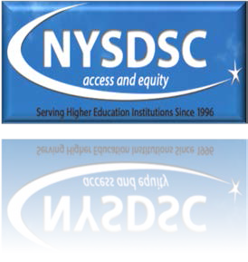NYSDSC Spring 2017 Conference Proposal Form June 28-30, 2017 Clayton, NY.

We ask you to join your colleagues in an exchange of ideas and
expertise in Disability Services provision. We welcome proposals that expand the discipline in all areas regarding: classroom accommodations, testing accommodations, assistive technology, current trends in practice and research, understanding the law, mentoring, tutoring, online/hybrid course accessibility, grant writing, learning preferences, crisis management, building and marketing workshops/trainings for faculty and staff, motivating students, and many more…

PLEASE SUBMIT PROPOSALS TO: catherine.carlson@SUNYCGCC.EDU
Due by April 18th, 2017.

Thank you
Conference Planning Committee

PROPOSAL

Date:

Do you volunteer to have your session videotaped? Yes No

Title of Your Presentation:

Length of Presentation:
60 minutes 120 minutes

Abstract (130 words or less - formatting not applicable)

General Style of Presentation: Workshop Demonstration Round Table Panel Discussion Presentation

PRESENTATION FORMAT

File Format (PowerPoint, etc...)
Online Format
Verbal, Handouts, or Physical Display Only
Other: Please Specify Below

TECHNICAL NEEDS

Overhead Projector
Large Screen
Large note pad
LCD Projector
DVD Player
Laptop Computer
Other technical needs (please describe)

CONTACT INFORMATION

Primary Contact’s Name: Email: Phone Number: ( ) -

PRESENTER(S)

Please list names, titles and institutions as they should appear on the agenda:

Presenter 1: Title: Institution:

Presenter 2: Title: Institution:

Presenter 3: Title: Institution:

