THANKING OUR SPONSORS
Legislative Rally Day to Support Students with Disabilities in Higher Education

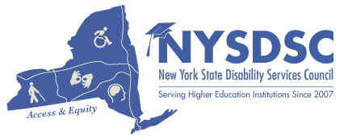

Thank you to the collaboration in NY State and all the students assisting with the day's accessibility accommodations, food, and planning! www.nysdsc.org

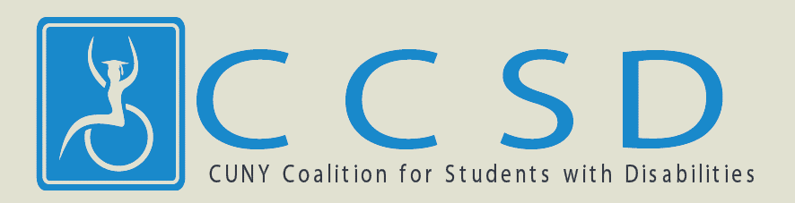

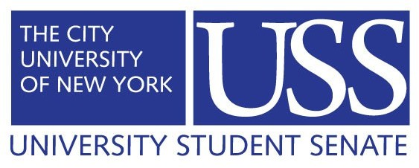
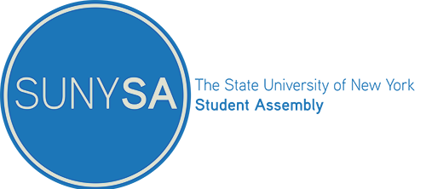
Thank you to all the student leaders that provided coordination and support for the day.

www.usscuny.org/
www.sunysa.org/
www.facebook.com/CCSDadvocates/

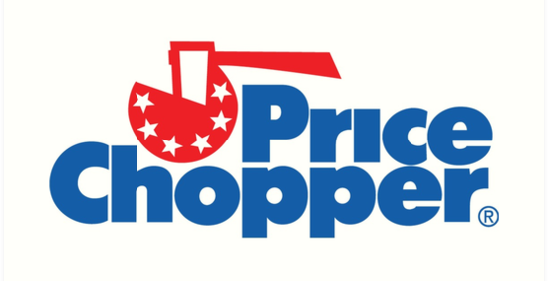
Water and granola bars! www.pricechopper.com/

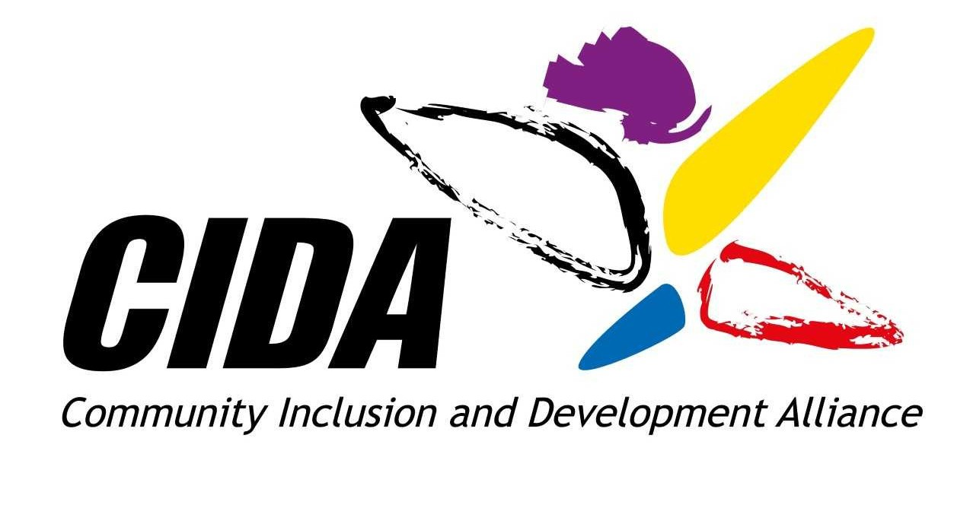
Thank you for your sponsorship toward accessibility https://cidainfo.com/

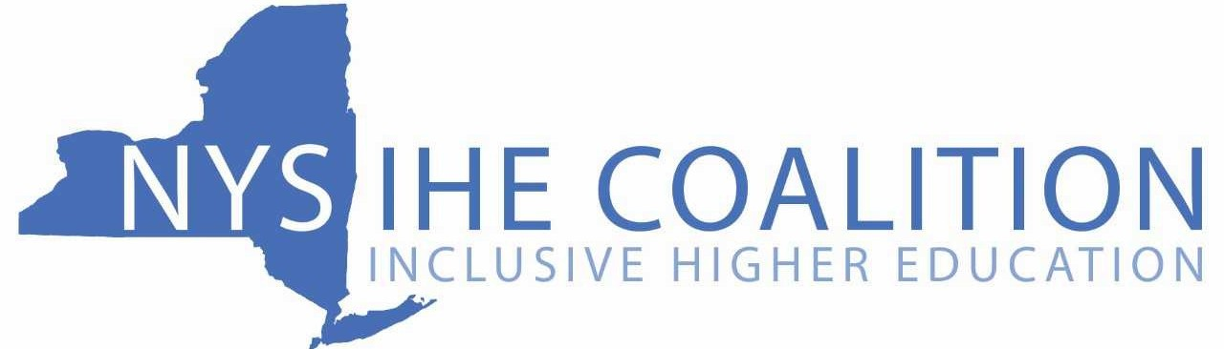

"Until we have equality in education, we won’t have an equal society.” Sonia Sotomayor

