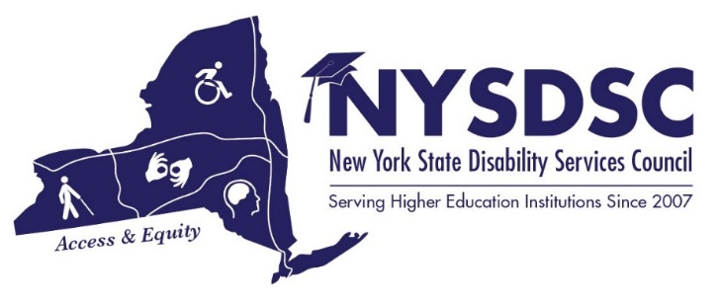

Spring 2018 Conference Proposal Form

June 27th-29th 2018

Deadline for final submission: Thursday, 3/23/18
NYSDSC Planning Committee final decision: by Tuesday, 4/10/18
Submit proposals to Nancy Carr carrn@sunyocc.edu
Note: All presentation material (ppt. handouts, etc.) must be submitted by 3/23/18 in accessible format.

CONTACT INFORMATION
Primary Contact’s Name:
Email:
Phone Number:

PRESENTER(S)

Presenter 1: Name as it should appear in the Agenda *

Presenter 1: Title as it should appear in the Agenda *

Presenter 1: Institution *

Presenter 2: Name as it should appear in the Agenda

Presenter 2: Title as it should appear in the Agenda

Presenter 2: Institution

Presenter 3: Name as it should appear in the Agenda

Presenter 3: Title as it should appear in the Agenda

Presenter 3: Institution

PROPOSAL

Title of Proposal *:

Length of Presentation
*note 120 minutes session may be divided into (2) 60 minute sessions.
Circle one: 60 minutes 120 minutes

Abstract (130 words or less - formatting not applicable) *

General Style of Presentation (Poster, Panel, Group work, Roundtable, etc...) *

Likely Presentation Format *

___ File Format (PowerPoint, etc...)

___ Online Format

___ Verbal, Handouts, or Physical Display Only

___ Other: Please Specify Below

Technical Needs *

___ Laptop & Projector (Provided by conference committee)

___ Speakers (Limited quantity available Upon Request)

___ Internet (Wi-Fi available through the venue)

___ Other Technical Needs (please explain)

Other Comments *

