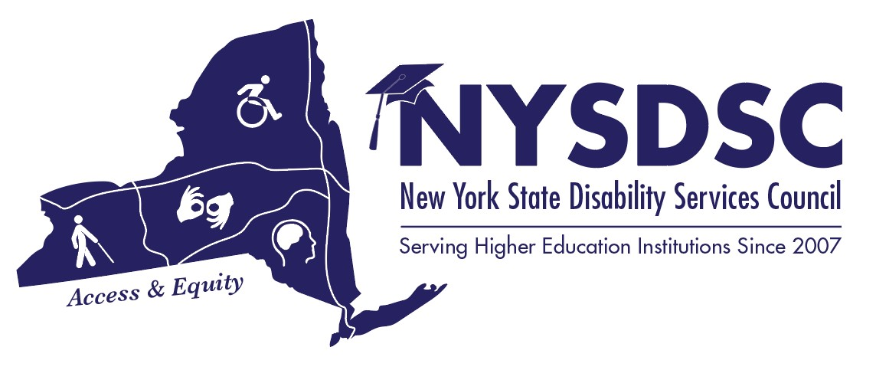New York State Disability Services Council
Fall 2019 Meeting

AGENDA

Day 1: Wednesday, November 6th, 2019

08:30 to 09:15 am Registration and Full Breakfast
Foyer DE

09:00 to 09:15 am Opening Remarks
Catherine Carlson, NYSDSC President
Salon E

09:15 to 10:35 am Effective Campus-Wide Communication
Salon DE
Dr. Mary Bonderoff
Chief Diversity Officer, SUNY Morrisville
Managing Microagressions
Difficult Campus Conversations

10:35 to 10:45 am Break

10:45am to 11:30am Updates from the New York State Education Department
Salon DE
Leigh Mountain, New York State Education Dept. – NYSED data update
Kevin Smith, Deputy Commissioner, ACCES-VR

Learn what is timely and relevant to disability professionals in New York State, including P-12 Special Education initiatives that effect our students, NYS ACCES-VR updated funding formula, data collection, legislative updates. Come prepared with questions!

11:30am to 12:00pm Open Dialogue: “I have a student /faculty/parent who….”
Salon DE
Facilitated by Carolyn Boone, Tompkins-Cortland Community College

Come to ask questions, present an issue, or simply come to listen! This is an opportunity to draw on the experience and expertise of your fellow colleagues who “have been there done that”. This session is designed for an interactive and productive on site conversations by the members of the Professional Development Committee. Come, gain practical, hands-on advice that you can implement to your daily activities in your own office.

12:00 to 01:00 pm Lunch
Empire Room

01:00 – 02:15 pm Concurrent Sessions

1.1 Building a Trauma-Informed Campus
Salon C
Chrys Ballerano
Sr. Director of Collaboration & Training
NYS Coalition Against Sexual Assault

NYSCASA conducts all of our projects through a trauma-informed lens which is inclusive of cultural diversity, the knowledge that trauma is widespread and should be assumed as part of individual’s history, and awareness that Adverse Childhood Experiences are often compounded by systemic oppression and discrimination.
Join an introductory discussion on what it means to be “trauma-informed” and learn where additional resources can support your work in creating safer campuses for students and all those who work on campus.

1.2 Brandon Brylinski, CPACC
Schenectady/Troy Room
IT Accessibility Coordinator
CIT Custom Development / Cornell University

As Cornell’s EIT Accessibility Coordinator, Brandon Brylinsky will discuss Cornell’s current two-year Top Sites Initiative. He’ll provide an overview about his background, the tech team reporting to him and be able to touch on his team’s process for website assessment, remediation of code, and coordinating with content owners to bring sites into WCAG 2.0 AA compliance. He’ll also be able to speak about Cornell’s process to launch Policy 5.12 on Web Accessibility Standards as well as integrating accessibility into the university’s procurement process for web-based applications and software. We can then move into a general Q&A after these initial talking points.

2:15 – 3:00 pm Building and Maintaining Relationships as a Neurodivergent Student
Salon E

Regina Varin-Mignano, LCSW-R, PhD
Manager –Health and Wellness Education and Grant Development
The Wellness Center
Principal Investigator - LaGuardia A.S.S.I.S.T. Program, SAMHSA Suicide Prevention Grant & ESL Strategies for Success Program
Adjunct Assistant Professor - Human Services Department
LaGuardia Community College/CUNY

3:00 to 03:10 pm Break

3:10 to 5:00 pm Updates on The Enhancing Supports for Students with Disabilities in Higher Education – LET’S GO!!!
Salon E

Train-the-Trainer Workshop: An interactive workshop designed to help us all understand the NYS legislative process and how it can create access to education for our students.

Specifically Covered:
- Introduction to legislative action and lobbying
- Review of our particular issue: Enhancing Supports
- How to develop small teams for local visits to legislators
- Define roles for those visits
- Loosely script the visits: articulating the ‘asks’
- Small group practice

Happy Hour – Chat’s Lounge - New members are encouraged to attend!

