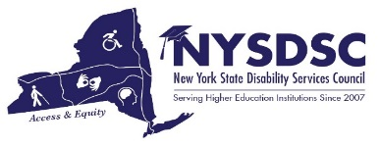
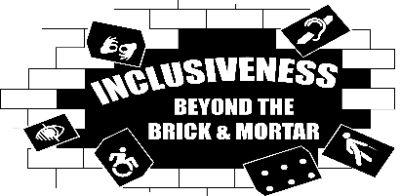
Welcome to the Spring 2019 NYSDSC Conference!

The NYSDSC Planning Committee would like to welcome each of you to the New York State Disability Service Council’s Spring 2019 Conference.
This year’s theme, “Inclusiveness Beyond the Brick and Mortar”, was developed in recognition of the changing landscape of education beyond the walls of our higher education institutions. Education has evolved into a lifelong, multi-leveled process for many of us. It is embedded in all areas of our lives – personally, professionally, socially and intellectually. Never before has knowledge, as an equalizer and an empowerment tool, transcended every corner of our living experience. Inclusion for all people is a critical factor in the strength of our societal construct, and so we must follow that conversation wherever it leads us, in whatever setting we find ourselves.
We have coordinated an engaging agenda that will be useful to new providers and seasoned professionals. The conference sessions were chosen to challenge your understanding of what “inclusion” actually stands for, accomplishes, achieves and redefines – a cycle of adaptation and improvement that never ends. We hope that you find kindred spirits and intellectual equals among our attendees – and we hope that you engage in discussions that challenge your ideas, your practices, and your future plans.
As usual, all of our attendees are encouraged to take back to their campus colleagues in other offices what is presented, making connections on a local level, inside and outside your institutions, so that we may be successful in creating a better living environment for our students, colleagues and families.
We truly appreciate your participation and, more importantly, wish you a very productive and rewarding stay!
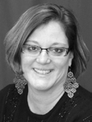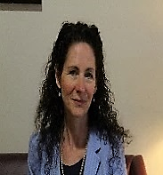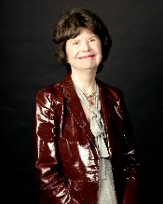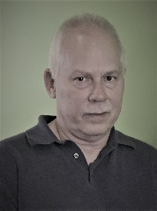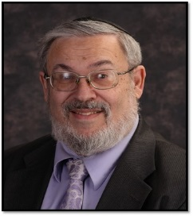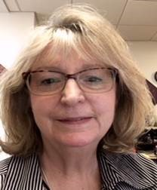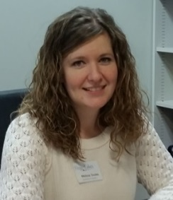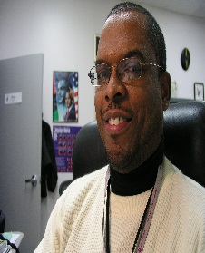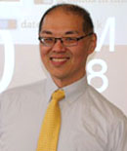
NYSDSC CONFERENCE PLANNING COMMITTEE MEMBERS
Catherine Carlson, Columbia-Greene Community College; Tamara Mariotti, Mohawk Valley Community College; Nancy Carr, Onondaga Community College; Don Pool, Jamestown Community College; Avery Horowitz, Touro College; Jean Vizvary, SUNY New Paltz; Melissa Soules, Finger Lakes Community College; Jhony Nelson, LaGuardia Community College; Daniel Chan, Hunter College

