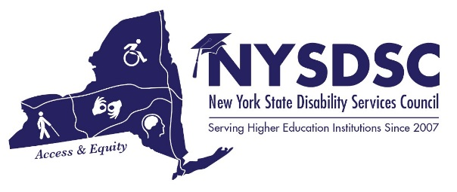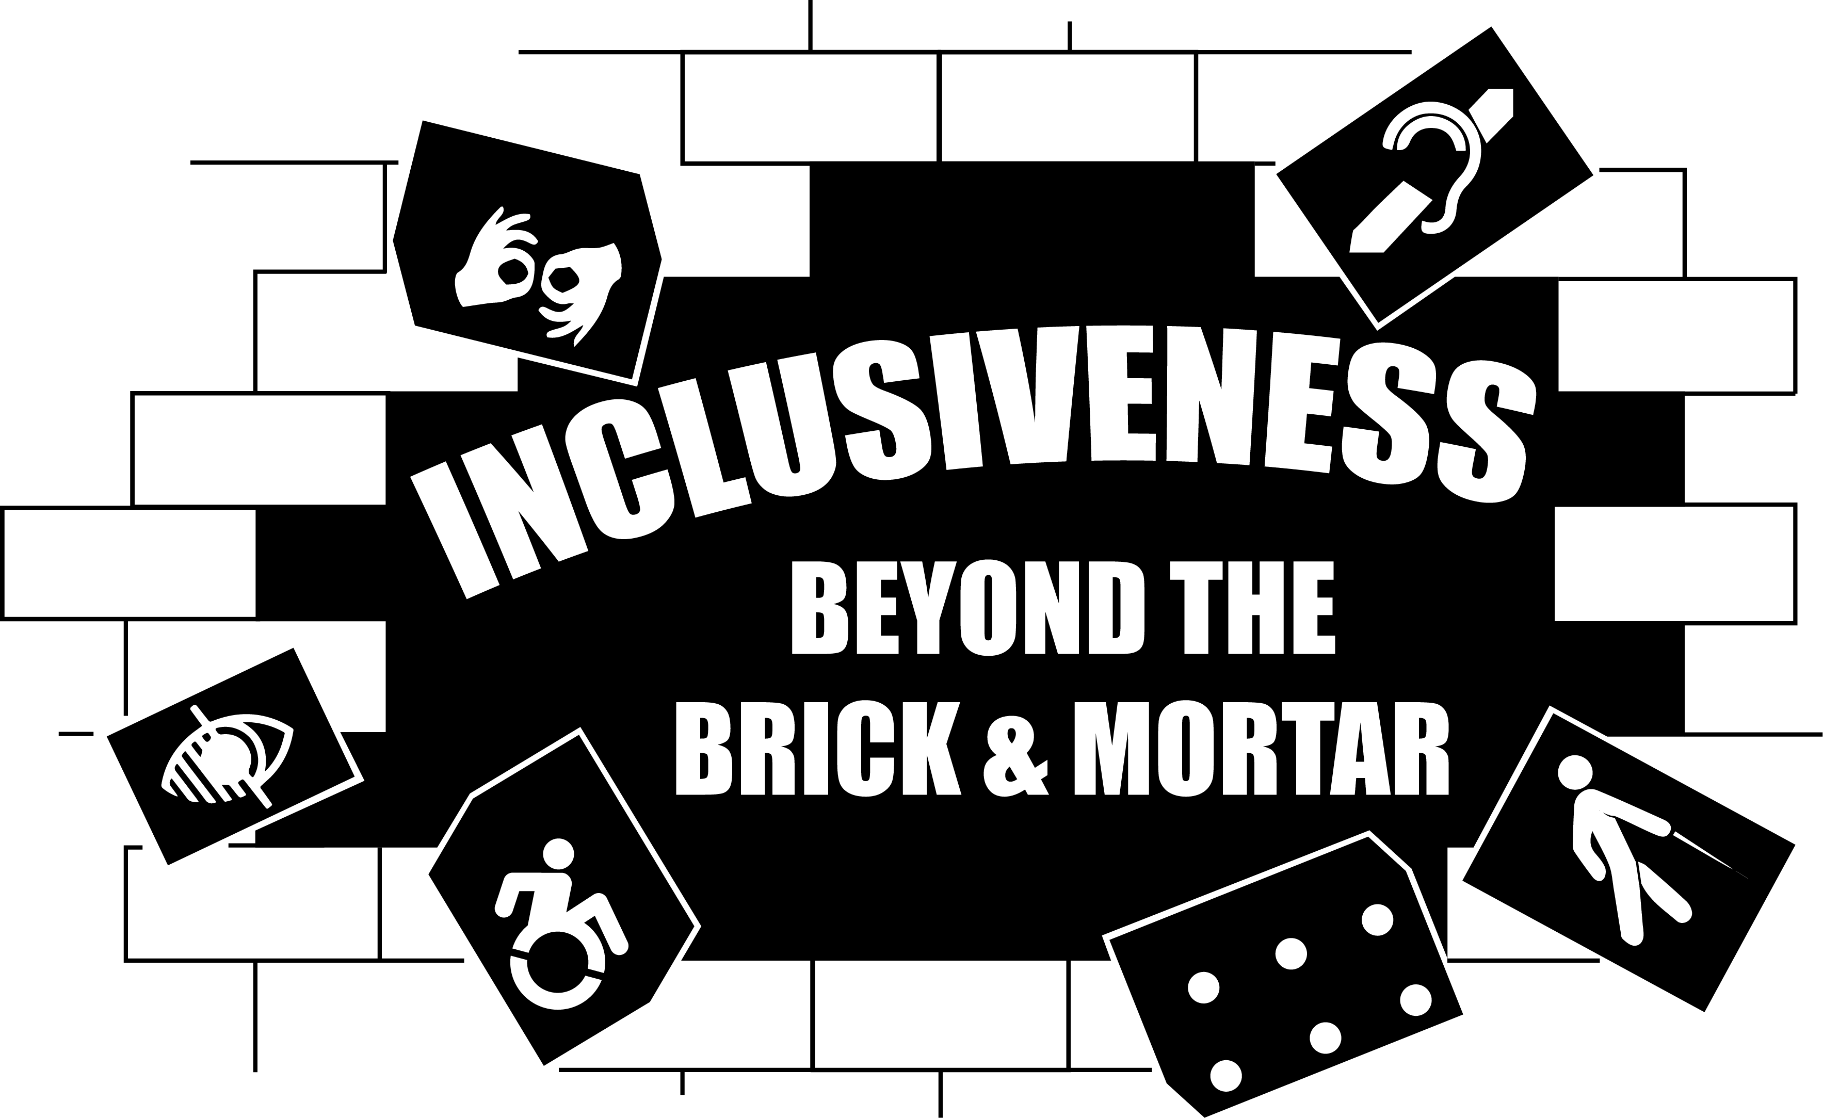

NYSDSC SPRING 2019 CONFERENCE AGENDA

Day 1: Tuesday, June 25th
08:00 to 09:25 am Registration and Full Breakfast
(TOWERS BALLROOM- FOURTH FLOOR)

09:30 to 09:55 am Welcome Note, Catherine Carlson, President

10:00 to 11:15am KEYNOTE – Dylan Emmons
(TOWERS BALLROOM- FOURTH FLOOR)

Diagnosed with Asperger's at age six, Dylan Emmons is a writer, public speaker and consultant working to improve understanding for and improving the quality of life of individuals on the spectrum. Dylan works with institutes of higher education, consulting with the instructors and professionals that work with students on the spectrum. He is a Reading and Writing Instructor at Borough of Manhattan Community College and lives in the Hudson Valley.

11:20am to 12:25pm Concurrent Session #1

  - Trending OCR Case Law and Open Questions
(TOWERS BALLROOM- FOURTH FLOOR)
Joy Purcell, J.D. and Marykate O’Neil, J.D.
Attorneys from the Office of Civil Rights will talk about trends and current case law, with a brief question and answer period following.

  - New Professionals Training
(TOWERS THIRD FLOOR EAST)
Jean Vizvary
Lauren Rodriguez
This session will be a “mini boot camp” for new professionals; covering the topics that are most useful and helpful to people new to disability-related work in higher education.

12:30 to 1:25pm Lunch (TOWERS BALLROOM- FOURTH FLOOR)

1:30 to 2:30pm NYSED Advisory Council on Post-Secondary Education for Students with Disabilities Updates:
Regent Christine Cea, Co-Chair of NYSED Advisory Council for Students with Disabilities in Higher Education; Kevin Smith, NYSED Deputy Commissioner of ACCES-VR; Dr. Christopher Rosa, Vice-Chancellor for Student Affairs, CUNY; Tamara Mariotti, Co-Chair of NYSED Advisory Council, MVCC Coordinator of Accessibility Resources.
(TOWERS BALLROOM- FOURTH FLOOR)

Updates regarding the proposed legislation: Enhancing Supports for Students with Disabilities in Higher Education one-house bill, future movement, NYSED and Advisory council updates.

2:35 to 03:25pm Concurrent Session #2

2.1 Intersection of Mental Health and Disability
(TOWERS BALLROOM- FOURTH FLOOR)
Don Pool, LMSW, Jamestown Community College
Lauren Rodriguez, PSY.D, Purchase College
Jean Vizvary, MS, Ed., SUNY New Paltz

As the number of students with Mental Health diagnoses rises on college campuses, confusion
increases about how, when, and what are appropriate accommodations. This session will briefly explore mental health symptoms and accommodate-able disability-related barriers (i.e. the difference between test anxiety and the need for accommodations for an Anxiety Disorder), followed by ample time for questions and answers.

2.2 Ally Implementation: Student, Faculty and Disability Service Provider Perspectives (TOWERS THIRD FLOOR EAST)
Kally Lauther, Adaptive Technology Coach, SUNY Delhi
Sumana Silverheels, Technology Accommodations Coordinator, Buffalo State College

Ally is an accessibility checking tool that can be widely implemented within different learning management systems. This session will provide attendees the processes that were implemented within two campuses to use Ally within their LMS. Ally has many available tools that allow supports and feedback for different administrative and instructional levels.
Presenters will demonstrate how the tool can be used by faculty to provide accessible instructional materials to students as well as use the data to provide targeted trainings within an institution. Student view and use will also be demonstrated.
4:00 to 5:00pm Disability History Museum Tour: Now on Exhibit: The Lives They Left Behind: Suitcases from a State Hospital Attic - $6 per person entry fee – Transportation on your own, but let’s carpool! (View separate flyer)
When Willard Psychiatric Center in New York's Finger Lakes closed in 1995, workers discovered hundreds of suitcases in the attic of an abandoned building. Many of them appeared untouched since their owners packed them decades earlier before entering the institution. The suitcases and their contents bear witness to the rich, complex lives their owners lived prior to being committed to Willard. They speak about aspirations, accomplishments, community connections, but also about loss and isolation. From the clothing and personal objects left behind, we can gain some understanding of who these people were before they disappeared behind hospital walls. We can picture their jobs and careers, see them driving cars, playing sports, studying, writing, and traveling the world. We can imagine their families and friends. But we can also see their lives coming apart due to unemployment, the death of a loved one, loneliness, poverty, or some other catastrophic event.
5:45 to 7:15pm After-Hours Event: Buffalo Tours Double Decker Bus Comedy Tour of Buffalo, NY – By Reservation Only
Members of the Regional Consortium WNY CCDA gathered information on tours in Buffalo. All attendees are welcome to sign up for the Double Decker Tour Bus Departs from Hotel Henry at 5:45 pm June 25th, 2019. Cost is $28.00 More information at the bottom of this page: http://nysdsc.org/Events

Day 2: Wednesday, June 26th

08:00 to 08:55 Full Breakfast
(TOWERS BALLROOM- FOURTH FLOOR)

09:00 to 05:15pm Information Available All Day (TOWERS BALLROOM- FOURTH FLOOR)

Visit The Vendors – An opportunity to visit the companies that produce assistive and adaptive technology for use by your students; and by your campus professionals

What’s Happening in My Neck of the Woods? - Consortia Networking – Gather information on post-secondary disability services professionals in your geographic location and get ideas as to current initiatives on the landscape, what members are doing to collaborate with high school educators, mental health agencies, independent living centers, etc.

09:00 to 09:55am Concurrent Session #3

3.1 Learn about providing SWAG- “Students with Accessibility Glitches” for students who are blind or visually impaired. (TOWERS BALLROOM- FOURTH FLOOR)
Tamara Mariotti, Mohawk Valley Community College (MVCC) and Roger Purdy, Ed.M., Le Moyne College and Makka Adam Djouma, MVCC student
When working with a student that is completely blind, what are the planning aspects to ensure that proper preparation takes place on the college campus. How do you, as a disability provider, assist students to become effective self-advocates.

3.2 Getting Benefits and Services to Work for You! #1 External Resources – Work Incentives, Maintaining Income and Obtaining Benefits (TOWERS THIRD FLOOR EAST)
Marge Gustas, Paralegal and Krista McDonald, Paralegal
Medicaid provides services like durable medical equipment when they are medically necessary to prevent or correct a condition that “interferes with the capacity for normal activity.” This session will discuss how to advocate for medical equipment that can help an individual achieve their capacity for normal activity and lead a more productive life.

3.3 Disability that Qualifies: A critical Analysis of Student Disability Service Rhetoric in Higher Education (TOWERS THIRD FLOOR WEST)
Rachel Elizabeth Traxler
This session will explore the language and rhetoric used in disability-related services and help participants re-conceptualize their services and language to become more inviting and inclusive. Participants will engage in discussions to help communicate to students and faculty effectively and still mindfully that many in their intended audience have different experiences and identities.

10:00 to 10:55am Concurrent Session #4

4.1 LGBTQ and Disability (TOWERS THIRD FLOOR WEST)
Sheila Figliotti, LCSW-R, SUNY Buffalo Counseling Services

Let’s discuss the intersection of disability and the LGBTQ population. We will explore the considerations for mental and physical health, the barrier created in an educational environment and appropriate accommodations.

4.2 Getting Benefits and Services to Work for You! #2 Durable Medical Equipment and Assistive Technology (TOWERS THIRD FLOOR EAST)
Marge Gustas, Paralegal and Krista McDonald, Paralegal
This session will discuss work incentives and services that are available to help achieve vocational goals without negatively affecting your income, while helping you maintain services and benefits that you may be eligible for, like health insurance.

11:00 to 11:55am Concurrent Session #5

5.1 TextHelp – Making content Accessible & Discoverable with Read&Write and EquatIO (TOWERS THIRD FLOOR EAST)
Justin Rodrigues

This session will explore creating and maintaining accessible content. Using products like Read & Write and EquatIO, professionals can help students with disabilities access the content they need. Features within software packages like above allow students to access materials that, traditionally, were inaccessible or required assistance from a human “helper.”

5.2 The New OZ (oh my)! Marijuana, CBDs, Vaping and Opioids
(TOWERS THIRD FLOOR WEST)
Sarah Hartman, AOD Prevention Coordinator, Onondaga Community College
Nancy Carr, Project Director, Onondaga Community College

This presentation will review what Onondaga Community College has done with two OASAS grants as a model. The presenters will also cover topics that you can bring back to your campus.
12:00 to 12:55pm Concurrent Session #6
6.1 How to ease the way to accessible and alternate formats for faculty and students – inside the VLE (TOWERS THIRD FLOOR EAST)
Tanja Stevns, Lars Ballieu Christensen - SensusAccess

Providing faculty, staff and students with effective accessibility and alt formatting tools is very important but having access to it directly within the virtual learning environment is even better. SensusAccess´s new LTI plug-ins will do just that and thereby ease the way to better accessible documents even further.
6.2 Assistive Technology Open Forum (TOWERS THIRD FLOOR WEST)
Access Technology Committee Members

This session is an open forum to discuss trends and new technology that helps students overcome barriers to their education. Our technology experts will discuss trends and innovations in technology, as well as facilitate discussion from the audience.

01:00 to 01:55 pm Lunch – Awards Ceremony (TOWERS BALLROOM- FOURTH FLOOR)

02:00 to 02:55 pm Open Dialogue: “I have a student /faculty/parent who….”
Facilitated by Tamara Mariotti, MVCC and Catherine Carlson, Columbia-Greene Community College (C-GCC) (TOWERS BALLROOM- FOURTH FLOOR)

Come to ask questions, present an issue, or simply come to listen! This is an opportunity to draw on the experience and expertise of your fellow colleagues who “have been there done that”. This session is designed for an interactive and productive on-site conversation by the members of the Professional Development Committee. Come gain practical, hands-on advice that you can implement to your daily activities in your own office.

03:00 to 03:55 pm Sector Meetings
      - CUNY (TOWERS THIRD FLOOR EAST)
      - SUNY (TOWERS BALLROOM- FOURTH FLOOR)
      - Independent (TOWERS THIRD FLOOR WEST)
      - Proprietary (TBA)

04:00 to 05:15 pm Wine & Cheese Cool-Down (TOWERS BALLROOM- FOURTH FLOOR)
Additional flyer available about vendor sponsors.

Day 3: Thursday, June 27th
08:30 to 09:25am Full Breakfast (TOWERS BALLROOM- FOURTH FLOOR)

Wrap-Up Session for New Professionals Training Attendees
(TOWERS BALLROOM- FOURTH FLOOR)
Jean Vizvary
Lauren Rodriguez
This breakfast session will finish the “mini boot camp” for new professionals and give the presenters and audience a chance to meet in an informal, relaxed setting.
Committee Meetings (TOWERS BALLROOM- FOURTH FLOOR)
Sit with your NYSDSC Committee(s) and discuss current initiatives and future possibilities for advancing the work of the committee(s). If you have not yet joined a Committee, pick one that sounds interesting and listen to the discussion.

09:30 to 10:25am NYSDSC Business Meeting (TOWERS BALLROOM- FOURTH FLOOR)

10:30 to 11:25am Providing Accommodations In Difficult Or Novel Higher Education Settings:
(TOWERS BALLROOM- FOURTH FLOOR)
Seth F. Gilbertson, Associate Counsel, State University of New York

Current accommodation issues that legal counsel for colleges and universities have been working on with regularity. Topics will include providing accommodations during student conduct proceedings, international and applied learning programs, digital and web accessibility and accommodating mental health in the classroom.
11:30 to 12:30pm Light Lunch Before We Send You On Your Way!

  - Thank you for joining us for our Spring 2019 Conference!

